BSI.IT.10.C13 – Config Authentication – CDA (2026)
IT RCSA – Configuration Management
Item | Detail
Control | BSI.IT.10.C13 – Config Authentication (Heracles 50539552)
Risk | [BSI.IT.10.R3 PW Config] Unauthorized access to systems and data due to failure to enforce strong password configurations may result in data compromise, system and business disruptions, financial loss, and regulatory noncompliance. (High)
Owner / executor | Ian Rojo
Relevance / nature / frequency | Key Control / Hybrid / In every operation
Testing period | 07/05/2025 – 01/04/2026 (semi-annual) – tested as sustainability testing of the open Action Driver
Prepared by / reviewer | Edward Morfa (IT RCSA) / Amanda Munoz Henry (Testing Manager)
Evidence | Folder BSI.IT.10.C13 Config Authentication/Evidence – files start with their E-number. Screenshots in Evidence/Screenshots.

Control statement
[BSI.IT.10.C13 Config Authentication] In every operation, Infrastructure Engineering have configured strong authentication settings/policies for operating systems on premise to align with the Authentication and Authorization Standard. Exception to authentication configurations must be approved by the CISO.
How to read this: each question has the answer first, then the reason, then where to look. 'E04d line 15' means evidence file E04d, line 15. 'E01 p.12' means page 12 of E01.
Evidence used
Ref | What it is
E01 | Authentication and Authorization Standard v13.0, approved 07/28/2026 – SUS.AAS.4.2.2.3-4.2.2.8 on p.10. The version in force for the period was not provided.
E02 | Windows Server Hardening Guide – 4.2 Account Lockout Policy (p.7), 2.3.7.3 machine inactivity limit (p.65)
E03 | Linux Red Hat Hardening Guide v3.0 – Local Ref 85-87 minlen, complexity, maxrepeat (p.16)
E04a-j | Windows security exports for the 10 servers raised in 2025
E05 | Linux screenshots 11/03/2026 – pwquality credit settings for 4 servers
E06 | SEF exceptions approved 07/01/2025 – 07/04/2026 – the file is empty
E07 | Coverage period calculation
E08 | WP2 C13 2025 (prior year)
E09 | 2025 exception form (Windows idle timeout; Linux maxrepeat)
Test Plan | 2026 Test Plan, tab Open ADs, row 196 – AD 005056BCA24E1FD0B4A6A1173BF00BA4

Testing period
C13 was rated Weak on 12/19/2025, so it moves to semi-annual testing (Testing Procedure 4.1.2). The 2025 period ended 07/04/2025, so the next one is 07/05/2025 – 01/04/2026 (E07). But the control has an open Action Driver (target 09/30/2026). While an AD is open, CDA and CPA cannot be done; the control is checked through sustainability testing once the fix is in (Testing Procedure 4.1.3 and 4.5). The AD itself plans that test (mitigating action 'Authentication Hardening Sustainability Testing', 09/30/2026).
Design questions
1. Is the control designed with an appropriate frequency or trigger?
Yes. Settings are applied at build and kept by policy: the Windows domain policy sets the password, lockout and idle values on every server, and Linux uses pwquality / faillock / login.defs set at build. Applying it at build and enforcing it centrally is the right trigger for this risk.
Reference: E04a-j lines 4-11, 49; E03 p.16
2. Is there a defined audit trail/evidence which supports the execution of the control being performed?
Yes. The secedit export shows every Windows setting; Linux settings come from the config files with a command. Qualys compliance scans also report deviations. Observation: most exports carry no server name or date, and the Linux screenshots only show part of the settings.
Reference: E04a-j; E05
3. Is the control aligned with internal policies and/or applicable regulations?
Yes. The Windows values meet SUS.AAS.4.2.2.3-4.2.2.8: expiry 45 days, length at least 8 (set to 14), history 12 (set to 24), minimum age 1 day, complexity on, lockout after 5 tries and locked for at least 30 minutes or until an administrator unlocks (E01 p.10). Observation: the Windows guide recommends a 15-minute lockout duration (E02 p.7) and our servers use -1, which means locked until an admin unlocks. That is stricter than the guide and allowed by the Standard, but the guide and the Standard say it differently. The 2025 workpaper treated -1 as an exception; the exception form and AD talk about the idle timeout. The AD closure note should say clearly which setting was fixed.
Reference: E01 p.10; E02 p.7, p.65; E09
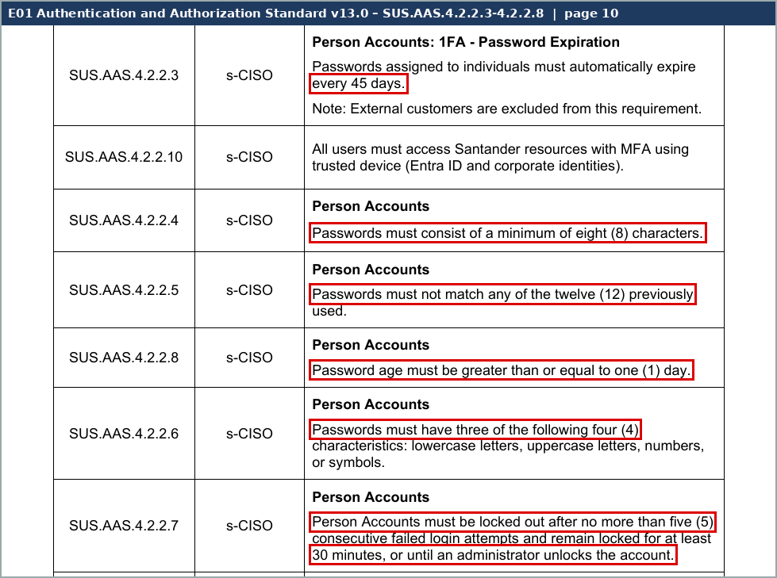
Screenshot 1 – C13_S4_AAS_passwords.png (Evidence/Screenshots)
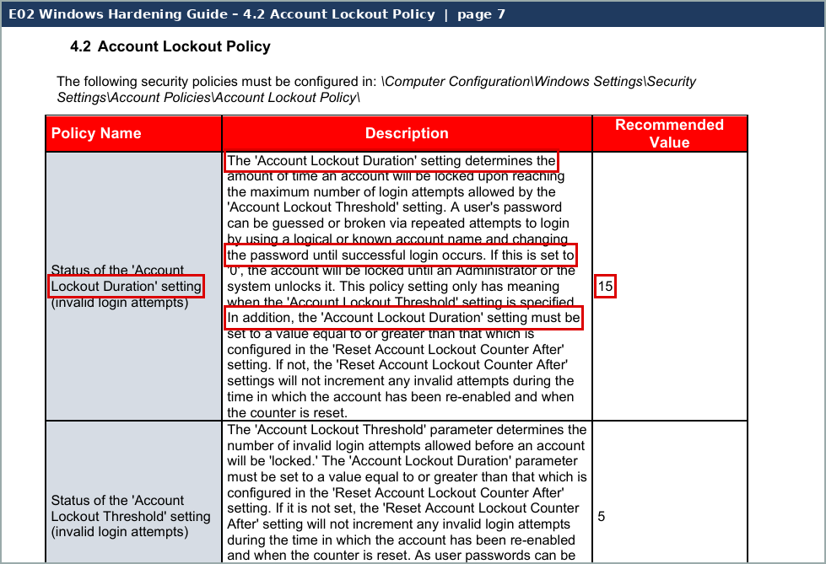
Screenshot 2 – C13_S5_Win_lockout.png (Evidence/Screenshots)
4. Are the thresholds for execution/resolution appropriate?
N/A. Not required – Key control.
5. To what level is the issue escalation process defined and implemented?
Partial. Deviations should be picked up by InfoSec's Qualys compliance scans and sent to Infrastructure; exceptions go to the SEF meeting for CISO approval (none in the period, E06). But the 2025 root cause was exactly that Qualys did not see these deviations, and we have not seen a scan or escalation from this period.
Reference: E09 root cause; E06
6. How reliable is the information which the control is dependent upon?
Moderately Reliable. System-generated exports, but 7 of 10 files have no server name inside and MIA-DC-TOFS and MIADCCTXLIC01 are the same file byte for byte. The Linux screenshots show hostname and time, but only the credit lines.
Reference: E04a-j (C13_S2); E05
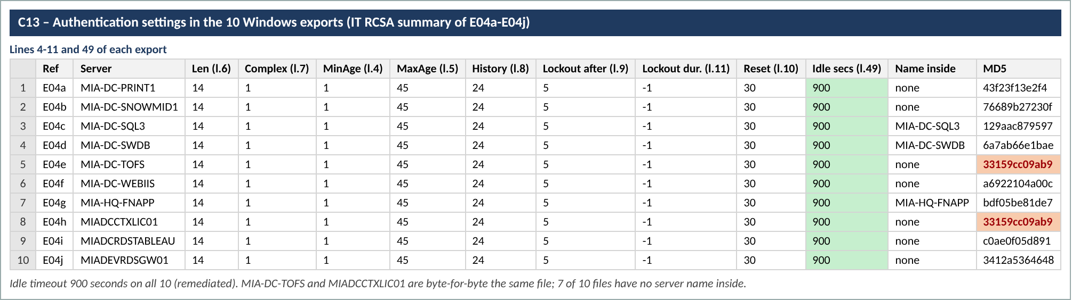
Screenshot 3 – C13_S2_export_summary.png (Evidence/Screenshots)
7. Is the process to obtain evidence of the control execution simple?
Yes. secedit and a grep take minutes. Ask for the hostname and date in the same screenshot or file.
Reference: E04a-j; E05
Walkthrough and sample of one
Walkthrough: [date and attendees to be confirmed – in 2025 the walkthrough was 06/06/2025 with Rober Perez, Jorge Cuadra and Yamel Perez]. Yamel Perez left the bank on 04/10/2026, so confirm who now owns the Linux build and hardening.
How it works. Windows servers get their password, lockout and idle settings from the domain security policy. Linux servers get them at build from /etc/security/pwquality.conf (and pwquality.conf.d), pam faillock / pwhistory and /etc/login.defs. InfoSec runs Qualys compliance scans against the hardening guides. Exceptions need CISO approval in SEF.
Why this is sustainability testing. In 2025 we found 15 deviations: Windows idle timeout not set on 10 servers and Linux maxrepeat = 0 instead of 3 on 5 servers (E09). The AD plans the fix by 06/01/2026 and our retest by 09/30/2026. So we retested the same 15 servers.
Sample of one – MIA-DC-SQL3 (Windows, one of the 10 raised in 2025)
What we checked | What we saw | Where | Result
Export belongs to the server | Server name inside the file (SQLServer2005SQLBrowserUser$MIA-DC-SQL3) | E04c | Pass
Idle timeout (2025 exception) | InactivityTimeoutSecs = 900 (15 min); guide asks 900 or fewer, not 0 | E04c line 49; E02 p.65 | Pass – fixed
Password length / complexity | 14 / on (Standard: at least 8, three of four types) | E04c lines 6-7; E01 p.10 | Pass
Password age / history | min 1 day, max 45 days, history 24 (Standard: 1, 45, 12) | E04c lines 4, 5, 8 | Pass
Lockout | 5 tries, duration -1 (until admin unlocks), reset 30 min | E04c lines 9-11; E01 p.10 | Pass (stricter than guide)

The Windows fix is in place on this server and the other settings meet the Standard.
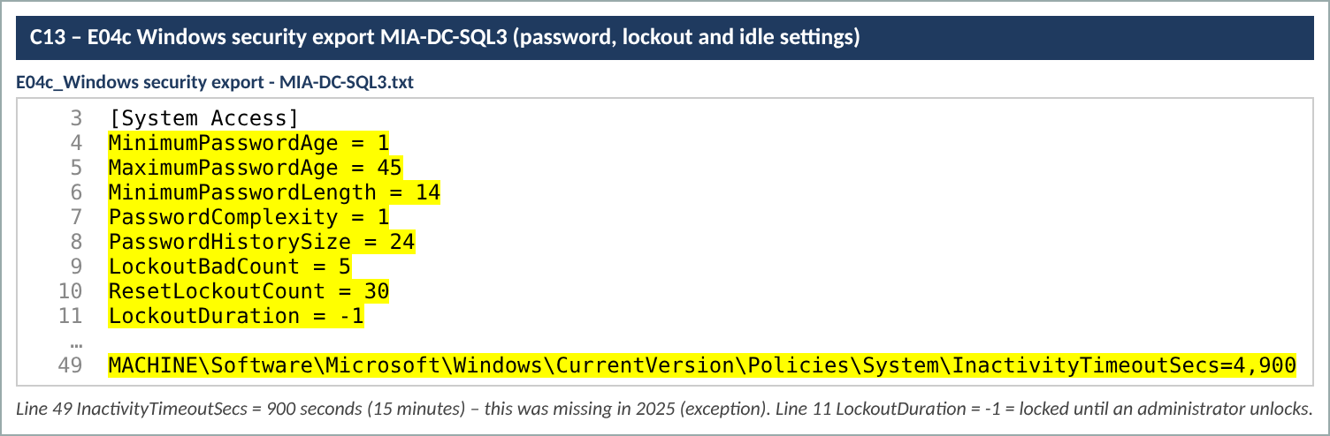
Screenshot 4 – C13_S1_SQL3_export.png (Evidence/Screenshots)
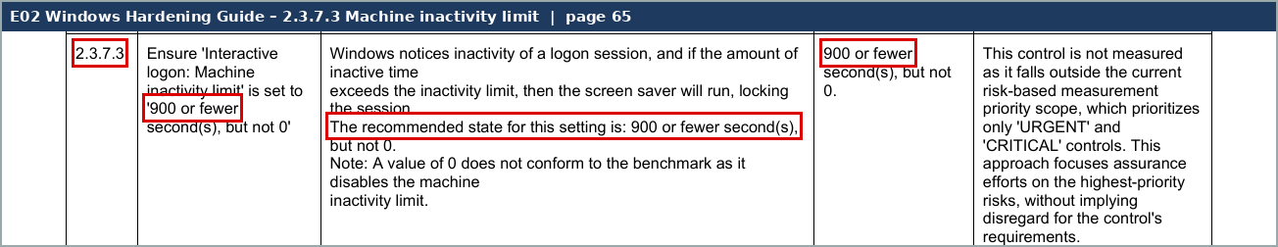
Screenshot 5 – C13_S6_Win_inactivity.png (Evidence/Screenshots)
Design observations
- (1) Windows guide (15-minute lockout) and the Standard (30 minutes or admin unlock) say it differently; servers use admin unlock.
- (2) Detection depends on Qualys, which missed these settings in 2025; no scan from the period has been seen.
- (3) Exports lack server name / date; two Windows files are identical; Linux screenshots show only part of the settings.
- (4) The Authentication and Authorization Standard in force for the period was not provided (only v13.0 of 07/28/2026).
Calculated rating: Satisfactory
The design fits the risk: settings come from central policy and match the Standard. Escalation is only partial because detection relies on scans that missed the issue last year. Calculated rating Satisfactory (Hybrid cap). The control stays Weak in GRC until the AD is closed.

